Chapter 3, Problem 59.

Rework Prob. 3.30 using mesh analysis.

Chapter 3, Problem 30.

Using nodal analysis, find v_{o} and i_{o} in the circuit of Fig. 3.79.
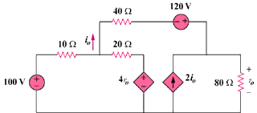
80 V
96 V

Figure 3.79
For Prob. 3.59.

